**Name: Sreelekshmi Anilkumar**

**Roll No:42**

**Batch: Mca B**

**Date:30-3-2022**

**NETWORKING & SYSTEM ADMINISTRATION LAB**

**Experiment No.: 2**

**Aim**

Familiarization of Hardware Components in a Computer

**Procedure**

Here are some common individual computer hardware components that you'll often find inside a modern computer. These parts are almost always found inside the computer case, so you won't see them unless you open the computer**:**

## What is Computer Hardware?

Hardware (sometimes abbreviated to HW) can be defined as the physical components that a computer system needs to function. This distinguishes it from software, which consists of written instructions that tell the physical components what to do.

## Internal and External Hardware Components

The components that make up hardware can be categorized as being either internal or external.

Internal components are those installed inside the computer, typical examples being the motherboard, power supply, and central processing unit (CPU).

External components are connected to the outside of the computer, these can also be referred to as peripherals, or peripheral devices, common examples being the monitor, keyboard, and mouse.

**HARDWARE COMPONENETS**

1. Motherboard
2. Central Processing Unit (CPU)
3. Power Supply
4. Random Access Memory (RAM)
5. Hard Disk Drive (HDD)
6. Video Card
7. Solid-State Drive (SSD)
8. Optical Disc Drive (e.g. BD drive, DVD drive, CD drive)
9. Card Reader (e.g. SD, SDHC)
10. Monitor
11. Keyboard
12. Mouse
13. Printer
14. Speakers
15. External Hard Drive

## 1. Motherboard

The motherboard (known colloquially as a mobo) is the main printed circuit board of a computer. It houses the CPU and operates as a hub that all other hardware runs through. It allocates power to the other components, co-ordinates them, and enables communication between them.

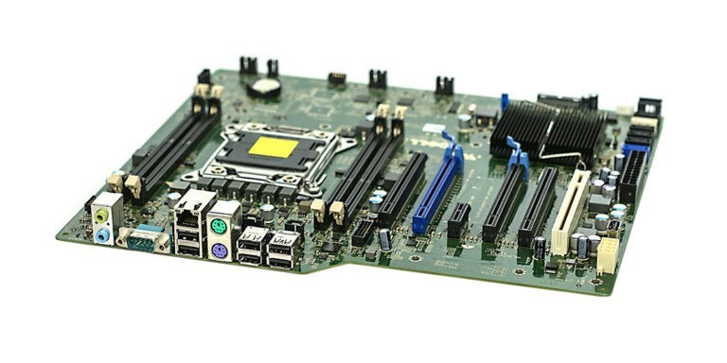

## 2. Central Processing Unit (CPU)

The central processing unit, or CPU for short, is responsible for processing all information from programs run by your computer. Each CPU has a clock speed, which is the number of instructions it can process in any given second, measured in gigahertz. The quality of a computer's CPU has a major effect on overall system performance.

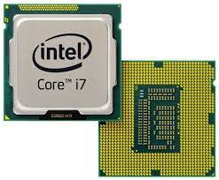

## 3. Power Supply

The main role of the power supply unit is to convert the alternating current (AC) from an outlet to direct current (DC). The computer components need DC to run normally. The power supply unit also controls voltage to prevent overheating issues. 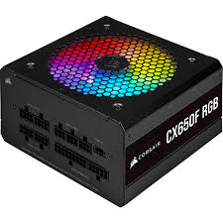

## 4. Random Access Memory (RAM)

Random Access Memory (RAM) is the physical hardware inside a computer that temporarily stores data. It is normally found in the memory slots of the motherboard. Its role is to serve as the computer's "working memory" for the information created by programs.

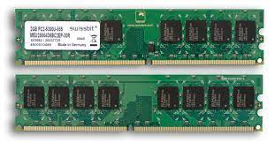

ADVERTISING

Generally speaking, the faster the RAM, the faster the processing speed at which memory moves data to other components.

## 5. Hard Disk Drive (HDD)

The hard disk drive is the main data storage device of a computer. This is where the operating system, software titles, and the majority of files are stored. Unlike RAM, hard drives are non-volatile, which means that they maintain their stored data even when powered off.

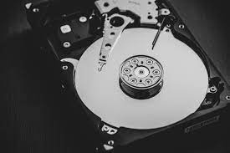

## 6. Video Card

The video card (also known as a graphics card) is an expansion card that enables the computer to send output images to a video display device such as a monitor. The video card typically installs via a slot on the motherboard.

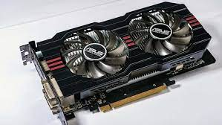

## Solid-State Drive (SSD)

Solid-state drives are designed to be housed inside the computer as an alternative to traditional hard disk drives. Although they look almost identical to traditional hard disk drives from the outside, they have no moving parts. This means that they use less power, access data faster, and are generally more reliable.

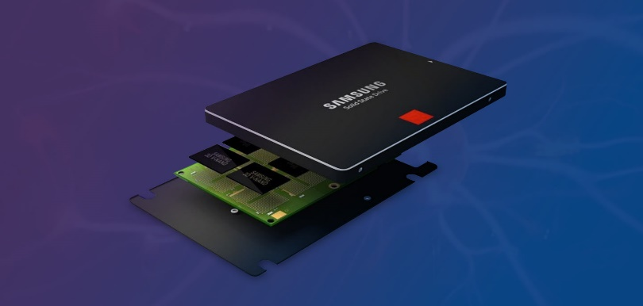

## 8. Optical Disc Drive (e.g. BD drive, DVD drive, CD drive)

An optical disc drive (ODD) uses laser light or or electromagnetic waves to read or write data onto optical discs. Common optical media designed for use with these types of drive are compact discs, DVDs, and Blu-ray discs. Optical disc drives can also be called disc drives, CD drives, DVD drives, and BD drives.

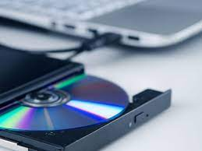

## 9. Card Reader (e.g. SD, SDHC)

Most personal computers and tablets have built-in memory card readers. This enables them to read data from memory cards, which are portable electronic storage devices used for storing digital information. Most contemporary memory cards use flash memory, although other memory technologies are currently being developed.

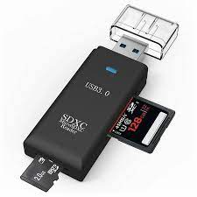

## 10. Monitor

The monitor is a hardware device that displays the video and graphics information generated by the computer via the video card. Monitors can also be called video display units, video display terminals, or simply as screens.

Older monitors were bulky and built using cathode ray tubes, but nowadays they normally use LCD technology and are lighter and thinner.

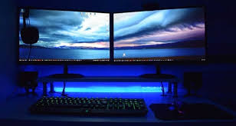

## 11. Keyboard

The keyboard is a typewriter-style device that enables users to interact with their computer. Users input text, characters, and other commands by pressing special buttons known as keys. Although the keyboard is normally considered to be an external hardware component, it is an essential part of most computer systems.

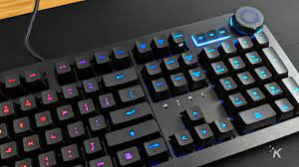

## 12. Mouse

The computer mouse is a hand-held pointing device used to manipulate objects on a computer screen. The standard modern mouse is able to direct a cursor using optical sensors. Most mouses also have two buttons (left-click and right-click), used for selection and accessing menus, and a scrolling wheel.

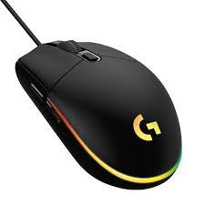

## 13. Printer

Printers are output devices that generate hard copies of electronic data stored on the computer, usually in the form of text or images on paper. The most common types of modern printer use inkjet or laser technology, and connect to the computer either via the computer's USB port, or via WI-FI.

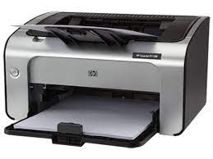

## 14. Speakers

Computer speakers are a common output device and are used for listening to music, movies, and other audio. They are available in a range of different qualities and prices, the more sophisticated versions having an additional subwoofer to provide enhanced bass output.

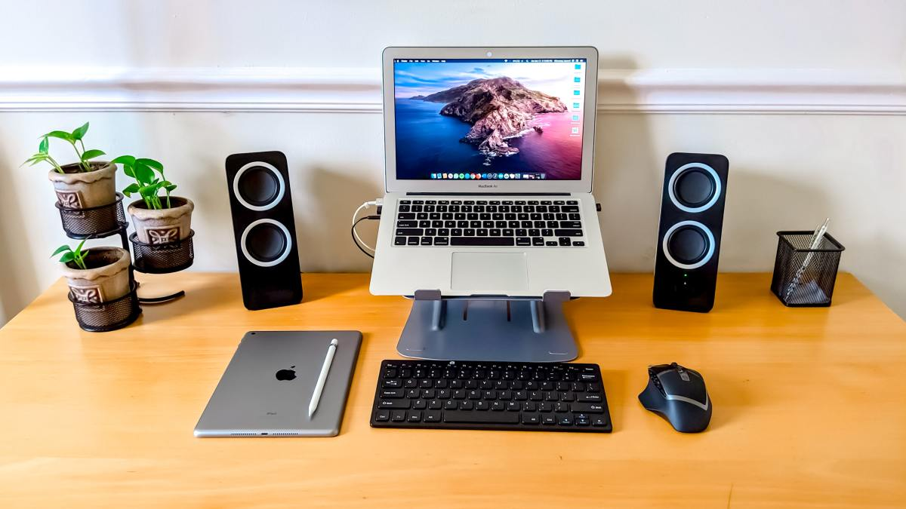

## 15. External Hard Drive

An external hard drive is a drive that typically connects to the computer's USB port. Some draw power from the computer via the data cable, others need an AC wall connection.

The main benefit of an external drive is their portability, you can carry relatively large amounts of data around with you, or transfer data between different computer

